DOCUMENT CONTROL SHEET
Business Unit | Corporate Services, MSLETB
Work Category | Customer Service Charter
Document Title | Customer Service Charter
Document No. | V3

Rev (per footer) | Status | Author(s) | Reviewed By | Approved By | Office of Origin | Issue Date
V1- D01 | D01 | JK | OR/JK | SMT  6th December 2019  Noted by Board  10th December 2019 | HQ, Castlebar | 10th  December,  2019
V2 | D01 | JK | OR/PH | SMT  10th January, 2022  Noted by Board  18th February, 2022 | HQ, Castlebar | 18th February,  2022
V3 | DO1 | JK | MMcD/CL/JK | SMT  15th June, 2026  Date  Noted by Board  Date  23rd June, 2026 | HQ  Castlebar

Contents
1. INTRODUCTION 3
2. MSLETB CORE VALUES 4
3. CUSTOMER SERVICE ACTION PLAN 5
4. COMPLAINTS 8

INTRODUCTION

Mayo, Sligo and Leitrim Education and Training Board (MSLETB) was established in accordance with the Education and Training Boards Act, 2013 and is one of sixteen Education and Training Boards (ETBs) nationally in Ireland.
MSLETB provides education and training to a diverse range of learners across Mayo, Sligo, and Leitrim through Further Education and Training Centres, and Schools. The Head Office of MSLETB is in Castlebar, County Mayo, with additional administration offices in Quay Street, Sligo and Carrick -On -Shannon, County Leitrim. The Education and Training Board is centrally managed through three Directorates: Further Education and Training, Schools, and Organisational Support and Development.

We continue to work with partners and stakeholders to improve the delivery of education and training services, to lead and to respond effectively to ever-changing emerging needs locally, nationally and internationally. We strive to provide excellence in all that we do and are committed to improving the level of customer service to meet the needs of the individual, businesses and the community.

Our Customer Service Action Plan describes in detail how the commitments and standards set out in the Customer Charter will be delivered and evaluated by MSLETB.

The Customer Service Charter outlines our commitment to providing services to our customers in accordance with the Twelve Principals of Quality Service for Customers and Clients of the Public Service. It further defines our service and informs customers of contact and feedback mechanisms.

OUR CUSTOMERS

INTERNAL CUSTOMERS | EXTERNAL CUSTOMERS
Teaching Staff, Special Needs Assistances | Pupils, Students, Parents / Guardians
Tutors | Adult learners
Administrative Staff | Young people and youth workers
Ancillary Staff | Trade Unions
All other staff in the employment of MSLETB | Members of the public and communities throughout our region
Board Members and Boards of Management | Government Departments & other Agencies and Bodies with whom MSLETB communicates

MSLETB is dedicated to openness and transparency in all aspects of our work. This ranges from how we develop policy to our engagement with individuals, businesses, community and the Departments of Education and Youth and Further and Higher Education, Research, Innovation and Science.

MSLETB CORE VALUES

Our core values support us in our commitments to continually improve the quality of learning experiences for all learners. They enhance our capacity to do our work well in our dealings with external and internal customers.

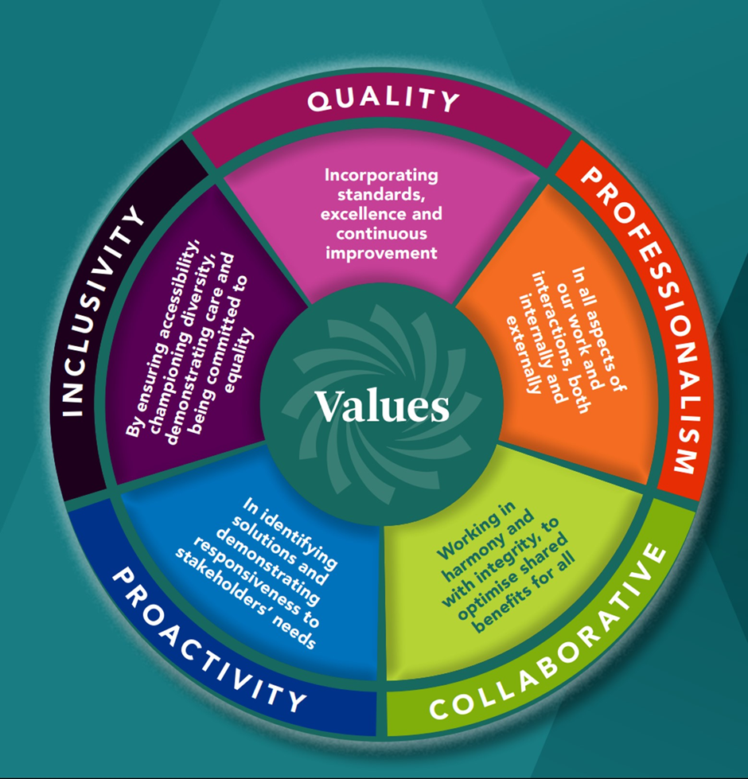

CUSTOMER SERVICE ACTION PLAN
Measuring and Evaluating Performance
Our customer service performance is monitored and measured against the 12 Principles for Quality Customer Service for customers and clients of the Public Service, our commitments as set out in our Customer Charter and the number of complaints we receive. Set out below are each of the twelve Principles for Quality Customer with our actions.
Principle | Action by MSLETB
1. Quality Service Standards
Publish a statement that outlines the nature and quality of service which customers can expect and display it prominently at the point of service delivery. | - Quality is identified as one of MSLETB’s Core Values. Our Customer Charter reflects our commitment to delivering the highest quality of service in all MSLETB activities.
 | - We will offer continuous learning and development opportunities to our staff to ensure consistency in delivering high quality customer service.
 | - Our Charter is published on our website www.msletb.ie and available at our reception areas / entrance to all buildings
2. Equality/Diversity
Ensure the rights to equal treatment, established by equality legislation, and accommodate diversity, so as to contribute to equality for the groups covered by the equality legislation (under the grounds of gender, marital status, family status, sexual orientation, religious belief, age, disability, race and membership of the Traveller Community).  Identify and work to eliminate barriers to access to services for people experiencing poverty and social exclusion, and for those facing geographic barriers to services. | - We are committed to ensuring equal delivery to all customers, without discrimination. We adhere to the principles as defined by the Employment Equality and Equal Status Legislation.
 | - We will continue to promote and support MSLETB’s Public Sector Duty Implementation Plan, embedding the organisational values of Inclusion, Respect, Social Justice and Empowerment.
 | - We are committed to continually improving the accessibility of our information and services and are actively working to ensure our content is accessible and tailored to meet the diverse needs of all our customers.
 | - We provide a co-educational, multidenominational environment for all pupils, students and learners.
3. Physical Access
Provide clean, accessible public offices that ensure privacy, comply with occupational and safety standards and, as part of this, facilitate access for | - We continue to ensure that our buildings meet the physical access needs of all customers and are committed to ongoing improvements to accessibility across all our locations.

Principle | Action by MSLETB
people with disabilities and others with specific needs. | - MSLETB’s Access Officer is available to address any questions or issues to facilitate access for people with disabilities and others with specific needs. Contact details accessofficer@msletb.ie.
4. Information
Take a proactive approach in providing information that is clear, timely and accurate, is available at all points of contact and meets the requirements of people with specific needs.  Ensure that the potential offered by information technology is fully availed of and that the information available on MSLETB web sites follows the guidelines on web publication.  Continue the drive for simplification of rules, regulations, forms, information leaflets and procedures. | - We aim to proactively provide information in a clear, timely, accurate and fully accessible way to all of our stakeholders.
 | - We endeavour to publish all relevant information on our website and have a strong presence on social media to ensure our message is delivered.
 | - Our Communications Team actively monitor our website and social media platforms for consistency and accessibility of information.
5. Timelines and Courtesy
Deliver quality services with courtesy, sensitivity and the minimum delay, fostering a climate of mutual respect between provider and customer.  Give contact names in all communications to ensure ease of ongoing transactions. | - We ensure that all customers are treated with courtesy and respect.
 | - We will ensure that all enquiries are dealt with as soon as possible and comply with our commitments outlined in our Customer Service Charter.
 | - We will ensure that all emails contain the relevant contact details.
6. Official Languages Equality
Provide quality services through Irish and/or bilingually and inform customers of their right to choose to be dealt with through one or other of the official languages. | - We continue to work on our compliance with the Official Languages Legislation.
 | - MSLETB’s Annual Reports, Service Plans and Strategy Statement and certain advertisements are published in both English and Irish.
 | - We comply with our obligations under the Irish Sign Language Act 2017.
 | - We have staff available to deal with callers who may wish to correspond through Irish.
 | - We will provide appropriate training to our staff to enhance their level of Irish.
7. Complaints
Maintain a well-publicised, accessible, transparent and simple-to-use system of dealing with complaints about the quality of Service Provided. | - Any complaints to MSLETB will be viewed with impartiality and dealt with promptly.
 | - We have a dedicated Customer Service Page on our website which includes our Customer Service Charter and Action Plan.

Principle | Action by MSLETB
8. Appeals
Similarly, maintain a well-publicised, accessible, transparent and simple-to-use system of appeal/review for learners/customers who are dissatisfied with decisions in relation to services. | - All appeals will be escalated to the appropriate manager to ensure that all customers are satisfied with the decision-making process of the organisation.
9. Consultation and Evaluation
Provide a structured approach to meaningful consultation with, and participation by, the customer in relation to the development, delivery and review of services.  Ensure meaningful evaluation of service delivery. | - We continue to consult with stakeholders in an effort to learn and improve our services.
 | - We will promote feedback from customers and staff by conducting customer service surveys, analyse results and report on our findings.
10. Choice
Provide choice, where feasible, in service delivery including payment methods, location of contact points, opening hours and delivery times.  Use available and emerging technologies to ensure maximum access, choice and quality of delivery. | - We, by the very nature of our structure, are flexible in our approach to the delivery of our services, ensuring that choice and options are available to all our customers.
 | - We will continue to provide our services using innovative and evolving technologies to meet the requirements of all service users, offering full time, part time and evening classes.
11. Better Co-ordination
Foster a more co-ordinated and integrated approach to delivery of public services. | - We continue to work with all our stakeholders, including our pupils, students and learners, to strengthen our approach to the delivery of services.
12. Internal Customer
Ensure staff are recognised as internal customers and that they are properly supported and consulted with regard to service delivery issues. | - We value our team at MSLETB and will continue to collaborate and consult with them to ensure they are properly supported and consulted in regard of our service delivery plans.

COMPLAINTS
Customers who are not satisfied with our services have the right to complain. At MSLETB we acknowledge that there is always room for improvement and welcome feedback.

We will endeavour to assist you in resolving your issue and will conduct all interactions with courtesy and respect. We ask that you engage with us in a similarly courteous manner.

Complaints should normally be made within twelve months of the event or within twelve months of the complainant becoming aware of the issue. However, MSLETB reserves the right to consider complaints outside this period where there are reasonable grounds for the delay, having regard to the circumstances of the case.

How to make a complaint

- Endeavour to resolve it locally:
If you are dissatisfied with the quality of the service provided or with how it was delivered by MSLETB, please raise your concerns at a local level in the first instance by contacting the relevant Manager in the Office, School or Centre concerned.

If you remain dissatisfied and wish to make a formal complaint, you can do so as follows:

- Formal Complaint:

All comments / complaints must be in writing and can be submitted by:

  - Post to MSLETB, Head Office, Newtown, Castlebar, Co. Mayo, F23 DV78
  - Email customerservice@msletb.ie
  - Phone Number 094 90 24188 (followed by written confirmation)
A complaints form is available on our website for your convenience www.msletb.ie

Customer Responsibilities:
To assist us in providing the best service, we ask that you:
- Provide full and accurate information.
- Complete all forms carefully.
- Make an appointment if you wish to see a particular member of staff.
- Treat our staff with courtesy and respect.

Acknowledgement of your complaint:
Complaints will be acknowledged and all responses will include a contact name, telephone number and email address. MSLETB will:
  - Acknowledge correspondence within 5 working days.
  - Respond to your correspondence within 15 working days, where practicable and subject to the complexity of the matter.

- Internal Appeals Process under MSLETB Customer Service Charter:

If you are not satisfied with the response to your complaint, you may:

- Contact the Head of Corporate Services, MSLETB, Head Office, Newtown, Castlebar, Co. Mayo, F23 DV78 for an internal appeal.
- Alternatively, you can email customerservice@msletb.ie and mark your email Internal Appeal in the Subject Line.
- The internal appeal is a review of the original decision based on the information available at the time and is not a re‑investigation of the complaint.

This is the second and final stage within MSLETB’s Internal Appeals Process. Where a final response has been issued and all available channels to resolve the complaint have been exhausted, and you remain dissatisfied after exhausting MSLETB’s Internal Appeals Process, you may refer your complaint to the appropriate Ombudsman.

- Appeal to Ombudsman / Ombudsman for Children:
Office of the Ombudsman:

The Office of the Ombudsman examines complaints from people who feel they have been unfairly treated by a public service provider. The Ombudsman will only deal with a complaint after it has first been dealt with through the internal complaints systems of MSLETB. The details for the Office of the Ombudsman are as follows:
- Address: Office of the Ombudsman, 6 Earlsfort Terrace Dublin 2 D02 W773
- Phone: 01 – 6395600
- Lo-call: 1890 22 30 30
- Email: complaints@ombudsman.ie
- Website: www.ombudsman.ie

Office of the Ombudsman for Children:
The Office of the Ombudsman for children examines complaints from children and young people under the age of 18 who feel they have been unfairly treated by a public service provider. The Ombudsman for Children will only deal with a complaint after it has first been dealt with through the internal complaints systems of MSLETB. The details for the Office of the Ombudsman for Children are as follows:

- Address: Millennium House, First Floor 52-56 Great Strand Street, Dublin 1, D01 F5P8
- Phone: 01 – 8656800
- Lo-call: 1800 20 20 40
- Email: oco@oco.ie
- Website: https://www.oco.ie/online-complaint/

